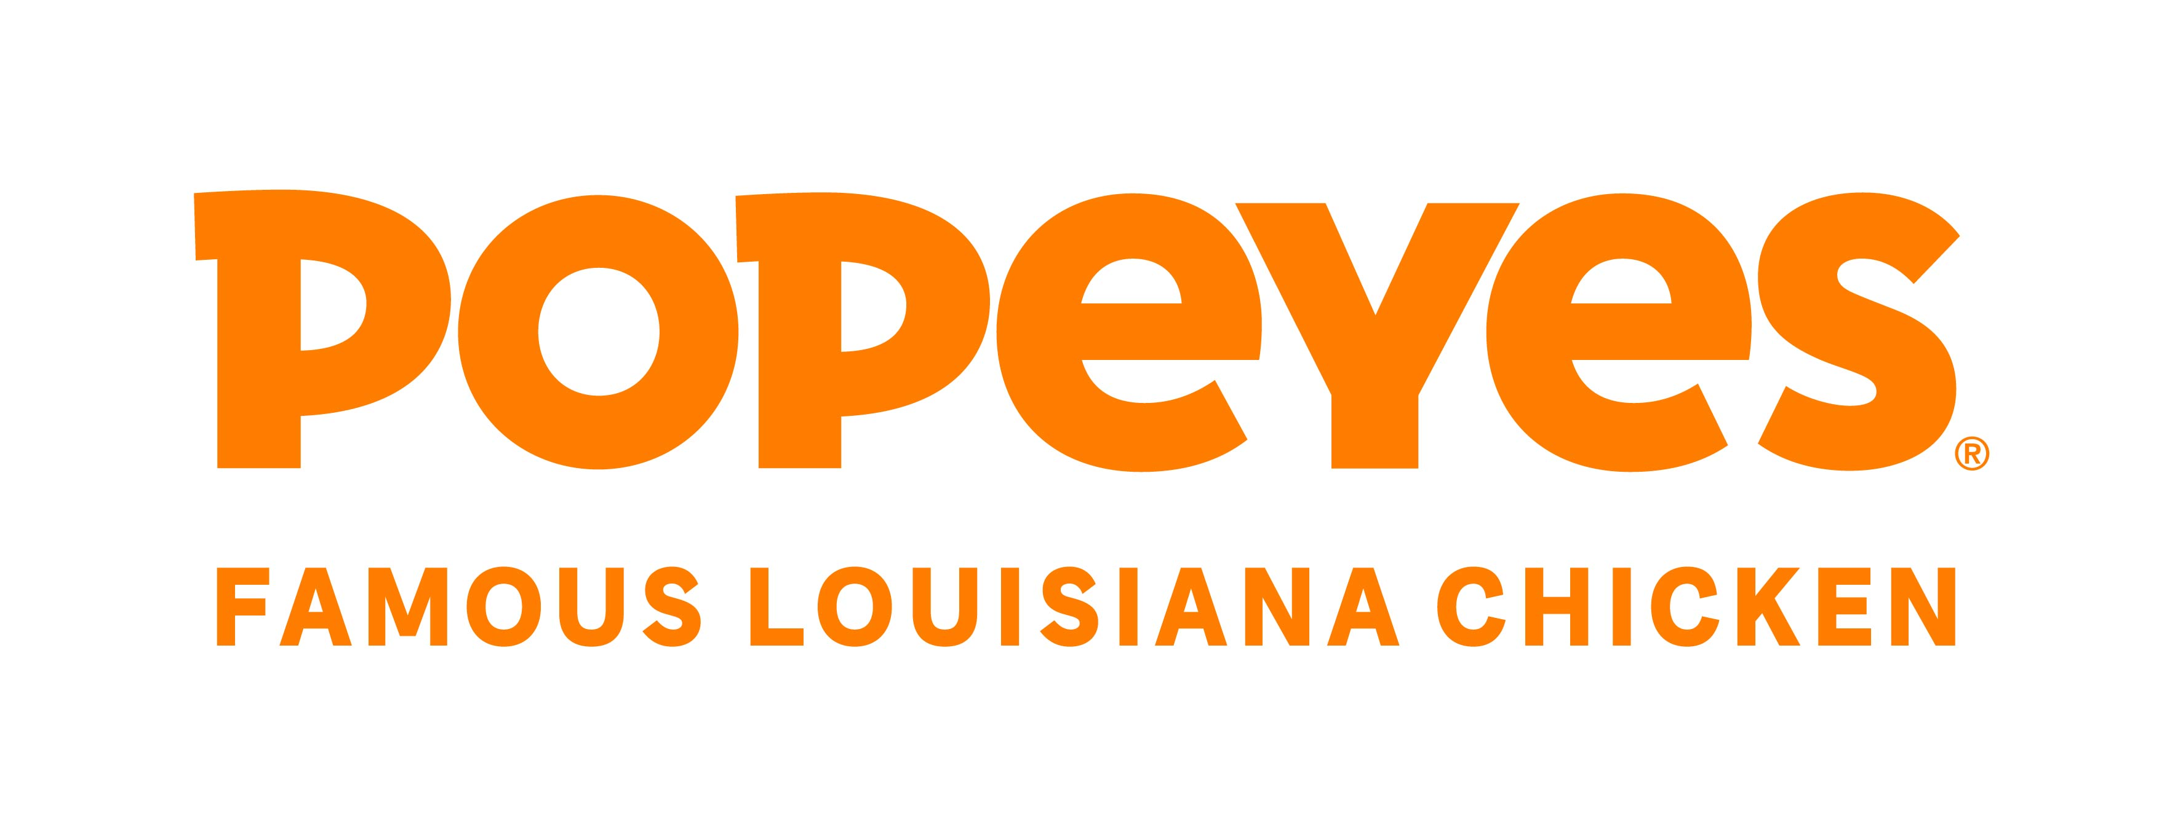

**Position Description**

|  |  |  |  |
| --- | --- | --- | --- |
| **Position Title:** | Marketing Lead | **Date:** | May 2024 |
| **Location:** | Tahua HUB, Takapuna, Auckland | **Reports to:** | Head of Marketing |
|  | | | |
| **Who we are – Popeyes NZ:**  **In 1972 in New Orleans, Louisiana, a taste sensation was born. What began with one small restaurant and one big idea turned into a craze that swept the USA and the world … and now is coming to New Zealand.** Let’s be honest here - we’re not an invented fast food, but boldly seasoned real food, hand-crafted (never mass produced) made by real cooks and deeply rooted in the traditions of Cajun cuisine.    We are part of a movement for taste. Popeyes are one of the fastest growing, ‘quick serve’ brands around, with a devoted following. Popeyes launched the now-famous Chicken Sandwich in 2019 (in the USA). Real food, bold flavours and simplicity at its core, it was nothing short of a culinary sensation. Social media is where our fans proudly share their love of the brand – even Beyonce and Jay-Z served Popeyes at their wedding!  We believe in the spice of life and the power of good food. Our love for spice, flavour and real food with heart. We’re all about manaakitanga… hanging out at Popeyes, sharing experiences and creating moments of joy. We’re building a new NZ business which will be soulful, proud, street smart, big hearted….and we want you to join our movement! | | | |
| **Why you’ll love this role:**  **Prepare to take the lead as the Marketing Lead for Popeyes Famous Louisiana Chicken in New Zealand! We have ambitious growth plans, and you'll be thrilled to join a team driven by a singular purpose: spreading happiness and joy through our love of great chicken. With your marketing expertise and dynamic approach, we aim for Popeyes to become an instant sensation. You'll craft marketing strategies and campaigns that cultivate a devoted following, with communities eagerly anticipating the next Popeyes experience.**  **This is a hands-on role that requires passion, dedication, and a strategic mindset. In this capacity, you'll have the freedom to unleash your creativity, deliver tangible results, and make a lasting impact. Your contributions will not only shape the success of Popeyes in New Zealand but also establish you as a leader in the marketing domain. It's an exhilarating journey where you'll have the opportunity to bring joy, flavor, and excitement to people's lives through the power of our irresistible chicken. Join us on this adventure, and together, let's make Popeyes the talk of the town in New Zealand!**  **Are you ready to dive in?** | | | |
| **What you’ll deliver in this role:** | | | |
| * **Develop and implement comprehensive marketing plans and campaigns to achieve business objectives, in alignment with the overall brand strategy and marketing goals.** * **Collaborate with cross-functional teams to execute marketing initiatives, including advertising, promotions, product launches, store launches and customer engagement programs.** * **Manage the media budget effectively, ensuring optimal allocation of resources to maximize ROI and drive sales.** * **Conduct market research and analysis to identify consumer trends, competitive landscape, and opportunities for growth.** * **Manage any brand partnerships and sponsorships ensuring activity aligns with the marketing calendar, brand strategy and goals.** * **Oversee event management and local marketing projects.** * **Oversee digital marketing efforts, including social media, email marketing, website optimization, and online advertising, to enhance brand visibility and engagement.** * **Coordinate with external agencies and vendors to execute marketing campaigns and projects, ensuring high-quality deliverables and timely execution covering media, PR and creative.** * **Support with branded merchandise acquisition and POS planning and distribution.** * **Analyse marketing performance metrics and KPIs and generate reports to evaluate the effectiveness of marketing initiatives, making data-driven recommendations for improvement.** * Stay informed about industry trends, best practices, and emerging technologies in the QSR and marketing fields, and apply relevant insights to drive innovation and competitive advantage. | | | |
| **What you’ll bring to the role:** | | | |
| * **Enthusiastic energy, inherent drive, and resilience, showcasing your ability to navigate through dynamic environments and drive progress, even in challenging situations. You have a growth mindset, seizing business opportunities, taking calculated risks, and consistently striving for improvement.** * **A proven track record of at least 7+ years in media agency or marketing roles, demonstrating your expertise in developing and executing successful campaigns that deliver measurable results.** * **Strong analytical skills to interpret data, identify trends, and make data-driven decisions that optimize marketing strategies. You stay informed about industry trends, emerging technologies, and best practices in marketing.** * **Strong financial acumen to manage media budgets effectively, ensuring optimal resource allocation to achieve maximum ROI and drive sales growth.** * **Experience in managing brand partnerships and sponsorships to ensure alignment with marketing calendar, brand strategy, and goals, fostering meaningful collaborations.** * **Proficient in overseeing event management and local marketing projects, leveraging creativity and strategic thinking to enhance brand visibility and engagement.** * **Strong project management skills to effectively plan, prioritize, and execute multiple campaigns simultaneously.** * **Excellent communication skills, both written and verbal,** **managing and collaborating with external agencies, vendors, or freelancers to execute digital marketing initiatives. You can effectively convey digital marketing strategies and results to stakeholders.** | | | |